**Music Recommendation System by Facial Emotion**

**Programs & Output :**

import os

import numpy as np

import pandas as pd

import seaborn as sns

import plotly.express as px

import matplotlib.pyplot as plt

%matplotlib inline

from sklearn.cluster import KMeans

from sklearn.preprocessing import StandardScaler

from sklearn.pipeline import Pipeline

from sklearn.manifold import TSNE

from sklearn.decomposition import PCA

from sklearn.metrics import euclidean_distances

from scipy.spatial.distance import cdist

from collections import defaultdict

import difflib

import warnings

warnings.filterwarnings("ignore")

import os

for dirname, _, filenames in os.walk('//input'):

    for filename in filenames:

        print(os.path.join(dirname, filename))

data = pd.read_csv("/content/drive/MyDrive/DATA ANALYTICS/data.csv")

genre_data = pd.read_csv('/content/drive/MyDrive/DATA ANALYTICS/data_by_genres.csv')

year_data = pd.read_csv('/content/drive/MyDrive/DATA ANALYTICS/data_by_year.csv')

artist_data = pd.read_csv('/content/drive/MyDrive/DATA ANALYTICS/data_by_artist.csv')

data.head(2)

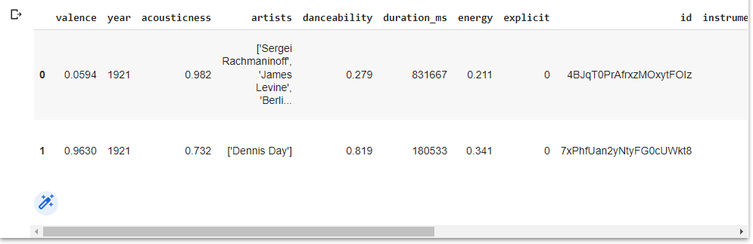

genre_data.head(2)

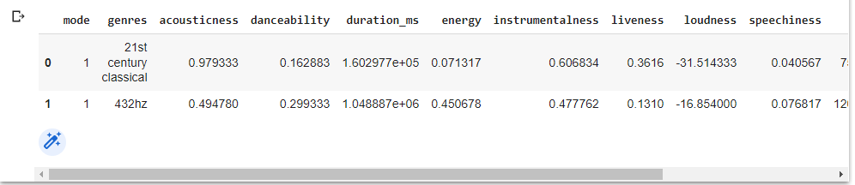

year_data.head(2)

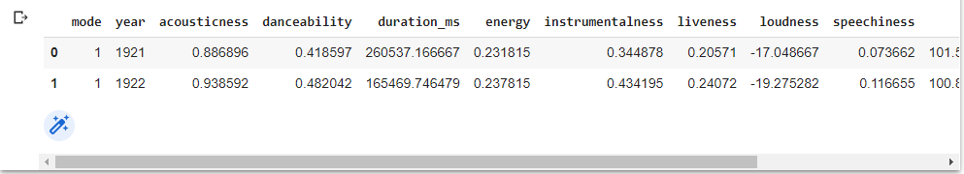

artist_data.head(2)

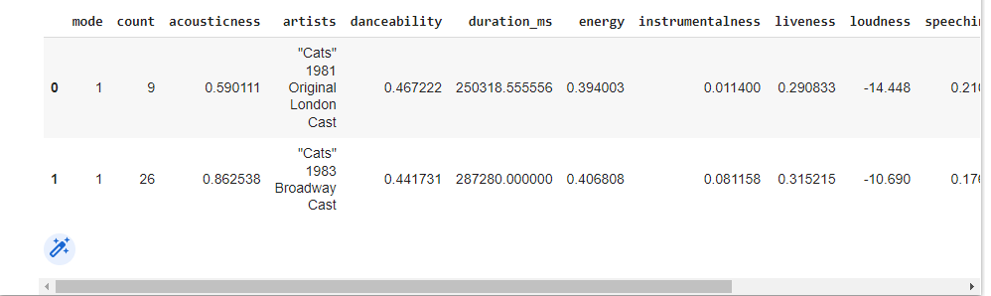

data.info()

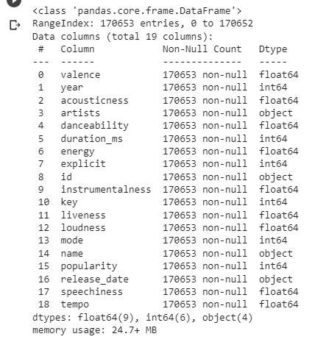

genre_data.info()

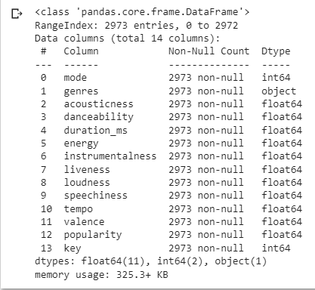

data['decade'] = data['year'].apply(lambda year : f'{(year//10)*10}s' )

sound_features = ['acousticness', 'danceability', 'energy', 'instrumentalness', 'liveness', 'valence']

fig = px.line(year_data, x='year', y=sound_features,title='Trend of various sound features over decades')

fig.show()

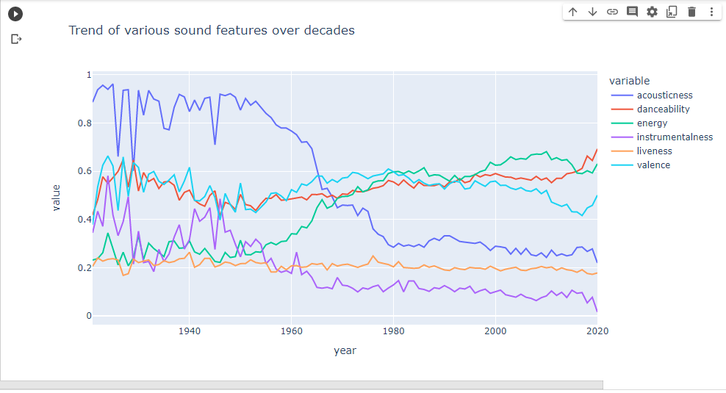

fig = px.line(year_data, x='year', y='loudness',title='Trend of loudness over decades')

fig.show()

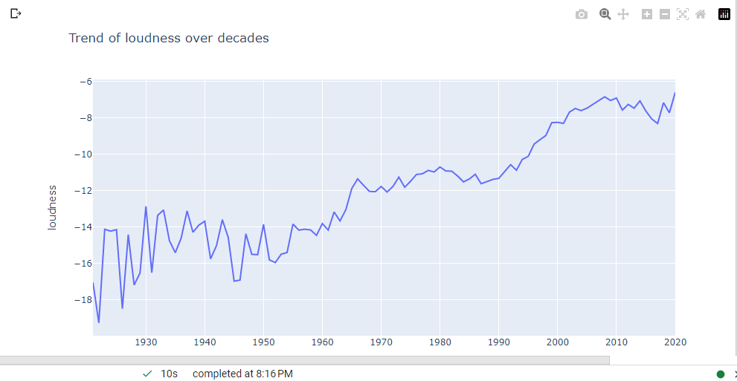

from wordcloud import WordCloud,STOPWORDS

stopwords = set(STOPWORDS)

comment_words = " ".join(genre_data['genres'])+" "

wordcloud = WordCloud(width = 800, height = 800,

                background_color ='white',

                stopwords = stopwords,

                max_words=40,

                min_font_size = 10).generate(comment_words)

plt.figure(figsize = (8, 8), facecolor = None)

plt.imshow(wordcloud)

plt.axis("off")

plt.tight_layout(pad = 0)

plt.title("Genres Wordcloud")

plt.show()

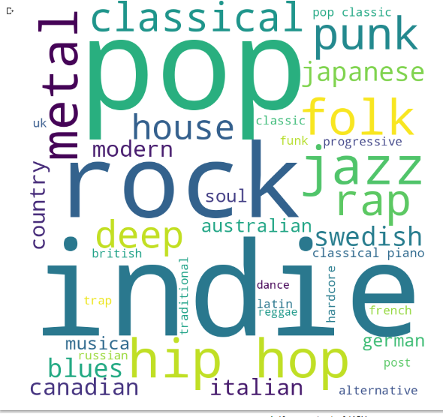

stopwords = set(STOPWORDS)

comment_words = " ".join(artist_data['artists'])+" "

wordcloud = WordCloud(width = 800, height = 800,

                background_color ='white',

                stopwords = stopwords,

                min_word_length=3,

                max_words=40,

                min_font_size = 10).generate(comment_words)

plt.figure(figsize = (8, 8), facecolor = None)

plt.imshow(wordcloud)

plt.axis("off")

plt.title("Artists Wordcloud")

plt.tight_layout(pad = 0)

plt.show()

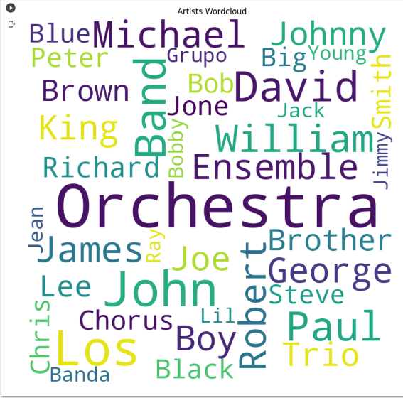

top10_popular_artists = artist_data.nlargest(10, 'popularity')

top10_most_song_produced_artists = artist_data.nlargest(10, 'count')

print('Top 10 Artists that produced most songs:')

top10_most_song_produced_artists[['count','artists']].sort_values('count',ascending=False)

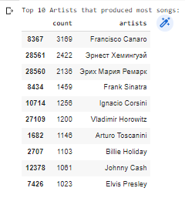

print('Top 10 Artists that had most popularity score:')

top10_popular_artists[['popularity','artists']].sort_values('popularity',ascending=False)

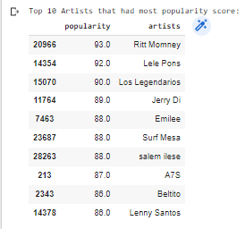

from sklearn.cluster import KMeans

from sklearn.preprocessing import StandardScaler

from sklearn.pipeline import Pipeline

cluster_pipeline = Pipeline([('scaler', StandardScaler()), ('kmeans', KMeans(n_clusters=12))])

X = genre_data.select_dtypes(np.number)

cluster_pipeline.fit(X)

genre_data['cluster'] = cluster_pipeline.predict(X)

from sklearn.manifold import TSNE

tsne_pipeline = Pipeline([('scaler', StandardScaler()), ('tsne', TSNE(n_components=2, verbose=1))])

genre_embedding = tsne_pipeline.fit_transform(X) # returns np-array of coordinates(x,y) for each record after TSNE.

projection = pd.DataFrame(columns=['x', 'y'], data=genre_embedding)

projection['genres'] = genre_data['genres']

projection['cluster'] = genre_data['cluster']

fig = px.scatter(

    projection, x='x', y='y', color='cluster', hover_data=['x', 'y', 'genres'],title='Clusters of genres')

fig.show()

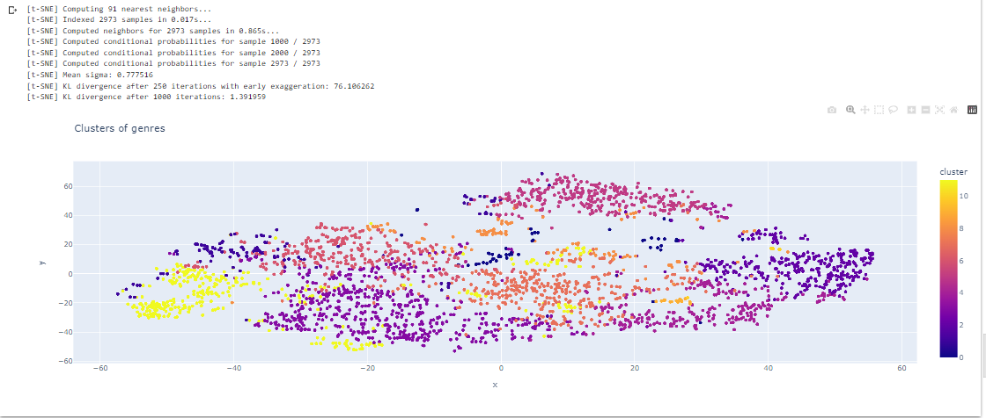

song_cluster_pipeline = Pipeline([('scaler', StandardScaler()),

                                  ('kmeans', KMeans(n_clusters=25,

                                   verbose=False))

                                 ], verbose=False)

X = data.select_dtypes(np.number)

song_cluster_pipeline.fit(X)

song_cluster_labels = song_cluster_pipeline.predict(X)

data['cluster_label'] = song_cluster_labels

from sklearn.decomposition import PCA

pca_pipeline = Pipeline([('scaler', StandardScaler()), ('PCA', PCA(n_components=2))])

song_embedding = pca_pipeline.fit_transform(X)

projection = pd.DataFrame(columns=['x', 'y'], data=song_embedding)

projection['title'] = data['name']

projection['cluster'] = data['cluster_label']

fig = px.scatter(

    projection, x='x', y='y', color='cluster', hover_data=['x', 'y', 'title'],title='Clusters of songs')

fig.show()

